Stephen Roach, Chief Economist  +1 (1)212 761 7153  stephen.roach@morganstanley.com |  | July 2001
 |  | Global Rebalancing
Global Investment Research

Morgan Stanley Dean Witter Global Economics

Stephen S. Roach Chief Economist 1-212-761-7153
David A. Jones 1-212-761-8019
Robert S. Brown Associate Director of Research 1-212-761-4574

Global

Joachim Fels Currency Economics 44171-425-6138
Karin Kimbrough 44171-425-6642
Stephen Li Jen Currency Economics 44171-425-8583
Melanie Baker 44171-425-8607
Joseph Quinlan Global Economics 1-212-761-4361
Rebecca McCaughrin 1-212-761-6295

Europe

Eric Chaney Euro Zone 331-5377-7305
Christel Rendu 44171-425-4182
Joachim Fels Euro Zone 44171-425-6138
Elga Bartsch Euro Zone 44171-425-5434
Mark Miller UK 44171-425-6643
Donui Agbokou 44207-425-7189

Emerging Markets Europe

Riccardo Barbieri Emerging Markets Europe 44171-425-6259
Serhan Cevik 44171-425-6234
Oliver Weeks Emerging Markets Europe 44171-425-4241

The Americas and Dollar Bloc

Richard Berner United States 1-212-761-3398
David J. Greenlaw United States 1-212-761-7157
Ted Wieseman 1-212-761-3407
Gray Newman Latin America 1-212-761-6510

Asia

Robert A. Feldman Japan 813-5424-5385
Karin Ri Japan 813-5424-5387
Takehiro Sato Japan 813-5424-5367
Andy Xie Non-Japan Asia 852-2848-5220
Denise Yam 852-2848-5301
Daniel Lian Non-Japan Asia 65-834-6745
Anita Chung 65-834-6746
Chetan Ahya India 91-22-2297940

Note: Daily updates of Morgan Stanley’s Global Economic Forum — a compilation of dispatches filed by the firm’s economists around the world —can be found on the World Wide Web of the Internet, at the following address: http://www.msdw.com.

Global Relapse

- So far this year, we have slashed our estimate of world GDP growth for 2001 to 2.5% from 3.5%. Relative to our baseline growth scenario of 4.2% prevailing early last October, these changes bring the cumulative downward revision to 1.7 percentage points over the past eight months. Our current baseline for 2001 represents nearly a 50% slowing in the pace of global activity relative to the boom-like outcome of 4.8% for 2000. The risk remains that there will be more cuts to come -- especially for 2002, where we are currently forecasting a rebound in global growth to 3.7%.

- Our call for a global downshift is dominated by a US economy that we think is now in mild recession. The US accounted for nearly 40% of total global growth in the five years ending in mid-2000. Not only is that 40% now in the process of going to “zero,” but the world is lacking an alternative growth engine to fill the void. Reflecting the new connectivity of globalization -- global trade, globalized supply chains, and balance-sheet adjustments of multinational corporations -- an engineless world is now on the brink of a rare synchronous recession.
- The balance of our forecast cuts have been spread around the world, initially skewed toward non-Japan Asia and the NAFTA bloc — regions of the world we judge to be most sensitive to US-led IT and other inventory linkages. We expect Europe to be hurt the least, given the region’s structural autonomy, fiscal support, and improving domestic demand; our downwardly revised European growth estimate for 2001 is 2.1%, still about double the gain we now expect in the US. In the climate we foresee, the world economy will have to face two “firsts” — the first recession of the Information Age and the first recession of globalization. That raises great uncertainty about the severity and duration of the cross-border repercussions of a US economy in recession. Four downside risks are most disconcerting: the possibility of further cuts to the developing world, a deeper recession in the US, the downside of the global IT and manufacturing cycles, and financial-market distress.

- With these revisions, our global growth forecast has pierced the lower bound of the 3.0–3.5% range that has been associated with global soft landings of the past. It is now right on the cusp of the 2.5% global recession threshold. For financial markets, the debate will shift increasingly to the shape of the coming recovery in the US and global economies. Given a likely purging of America’s structural excesses — negative personal savings, excess IT capacity, and a record current-account deficit — the odds favor more of a U- or L-shaped recovery than the V-shaped upturn now being discounted by the markets.

Global Relapse

We have cut our baseline global growth estimate to 2.5% in 2001, depicting a world economy on the cusp of recession.

With the US apparently in recession, the engine of global growth has likely been temporarily derailed.

Our estimates suggest global trade growth is slowing from 12.8% in 2000 to 4.3% in 2001 -- the sharpest slowdown on record.

World without an Engine

America’s leadership role in the global economy has been sharply diminished.

Trade linkages spread the US-led downshift, especially to East Asia and America’s NAFTA partners.

The world is lacking a candidate to fill the growth void left by a faltering US economy.

Global Transmission

Globalization is central to convergence; it reflects the increased connectedness of the world economy though trade flows . . .

. . . as well as through sharply expanded activity of multinational corporations.

A ubiquitous and transparent Internet adds a new technology-led dimension to globalization and international convergence.

Sources of Global Downshift

The lagged impacts of last year’s monetary tightening are restraining global growth in 2001.

A flattening of the wealth effect is also constraining global activity, especially in the wealth-dependent United States.

Rising corporate financing costs are also impeding economic activity.

Unwinding the Energy Shock

While crude oil prices are down from their highs, consumers are now feeling the full force of surging natural gas prices . . .

. . . yet in real terms, oil prices remain below levels of the early 1980s.

OPEC producers tend to save, or recycle, petrodollar windfalls — usually providing a boost to dollar-denominated assets.

Post-Bubble Global Economy

World equity prices have fallen 30% below their highs of last year.

The sell-off in global equities should hit the US the hardest.

America’s households are most exposed to the negative wealth effects.

A New Culture of Risk

Valuation strains are finally starting to take a toll on global equity markets.

While markets have capitulated on the near-term earnings outlook, optimism remains for 2002. | Overly-Optimistic 2002  2001  As of 1/1/01 As of 6/22/01 2002  ACWI Consensus Earnings 11% -1.0% 17%  S&P 500 Consensus Earnings 10% -5.6% 19.1%  World GDP 3.5% 2.5% 3.8%

US Stock Market: A New Era or Irrational Exuberance?
Source: Robert Shiller, Yale University, Morgan Stanley Economic Research

Rebalancing: Globalization of the Information Age

Global growth is likely to be increasingly driven by a convergence of global IT demand toward US norms. | 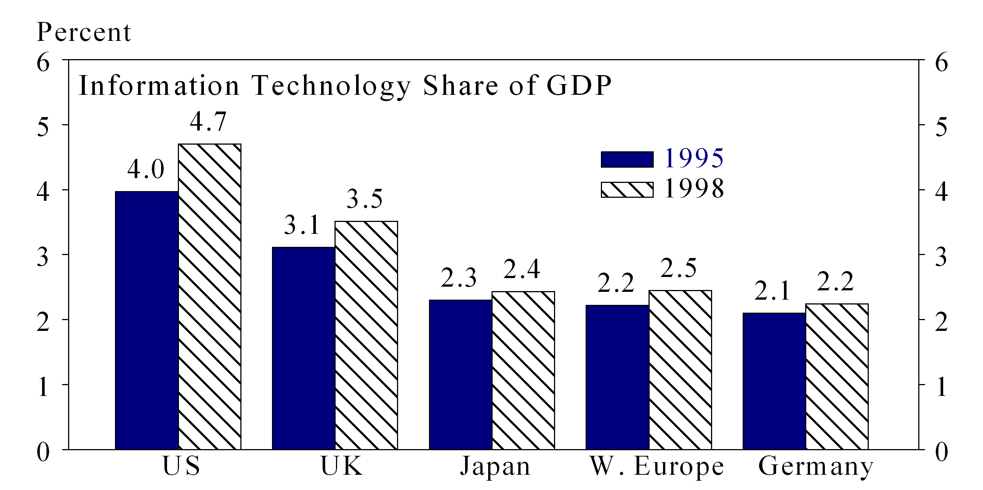

Europe should lead the demand catch-up, becoming the world’s largest IT buyer over the 2000–05 period.

Rebalancing: Globalization of Shareholder Value

The globalization of the equity culture is a key element of convergence toward America’s New Economy norms.

So, too, is a surge of cross-border M&A activity.

Moreover, there is now reason to believe that America’s venture capital culture is starting to go global.

Rebalancing: Globalization of Labor Markets

The service intensity of America’s work force has increased the potential for IT-led white-collar productivity enhancement.

Increased enrollment in higher education has separated America from the pack, making it better equipped to boost knowledge-worker productivity.

Immigration has played a key role in driving start-ups in America’s New Economy.

Rebalancing: Globalization of Innovation

America’s lead in the global innovation sweepstakes is starting to narrow.
Source: Stern, Porter and Furman “The Determinants of National Innovative Capacity”

The share of a nation’s workforce engaged in research activities is key to its innovative potential.
Source: OECD

R&D spending also is an important driver of innovative capacity.

Cyclical Rebalancing

Cyclical imbalances should work against the US; the absence of American labor market slack is notable in that regard.
Note: 1990 Germany data are for West Germany only; Italy data are from 1993

A savings-short US economy may well have to pay a premium to import foreign capital.

Given America’s massive external imbalance, that premium may take the form of a sharp depreciation in the dollar.

Perils of the Digital Divide

A wide gap currently exists between the haves and have-nots of Internet access.

Will the digital divide — income and wealth disparities between computer users and non-users — spark new global inequalities?

There is evidence of a digital divide within countries as well — at both ends of the prosperity spectrum.
Source: US Department of Commerce and China Internet Network Information Center (CNNIC)

Global Pension Challenge
A demographic time bomb is ticking around the world that makes the task of pension reform increasingly urgent.

Asia will account for a disproportionate share of global aging over the next 30 years.

Pension spending will rise sharply as a share of global GDP over the next 50 years.

A New Financial Architecture

• Likely Changes
– Infrastructure enhancements: Transparency, standards, compliance incentives, eliminating pegged exchange rates

– Coping with volatility: Expanded FX reserves, prearranged credit lines, debt restructurings, taxing capital inflows, new contagion lending facility

– Curbs on private creditors: Bail-ins, collective action clauses, encouraging longer-term financing, heightened oversight of highly leveraged borrowers

– IMF and World Bank: Refocusing and reform — less is more

• Unlikely Reforms
– New international authority

– IMF with expanded lender-of-last-resort capabilities

– Global credit insurance schemes

– Currency target zones

• Message from G-7
– Reluctant to coordinate, except in crises

– No endorsement of radical change in architecture

– Best international policy is collection of best domestic policies

– Exchange-rate regimes shift from fixed to floating

Europe’s Competitive Challenge

Europe is finally making progress in narrowing the global competitiveness gap.

The European model places a greater emphasis on the social contract of outsized benefits.

Europe lags the US in its commitment to information technology.

More to Come on Japanese Restructuring

Japanese restructuring is focused on boosting ROA back toward historical norms.

Restructuring tactics should focus on slashing labor compensation costs, we believe.

Corporate Japan will also have to rationalize excess capacity.

A Resilient Chinese Economy

After seven years of GDP deceleration, Chinese growth now seems to be picking up.

China’s export dynamic is beginning to feel the chill of the global slowdown.

In anticipation of WTO accession, foreign direct investment into China appears to be rebounding sharply.

Latin American Risks

Latin America remains dependent on foreign trade — although less so than Asia. | 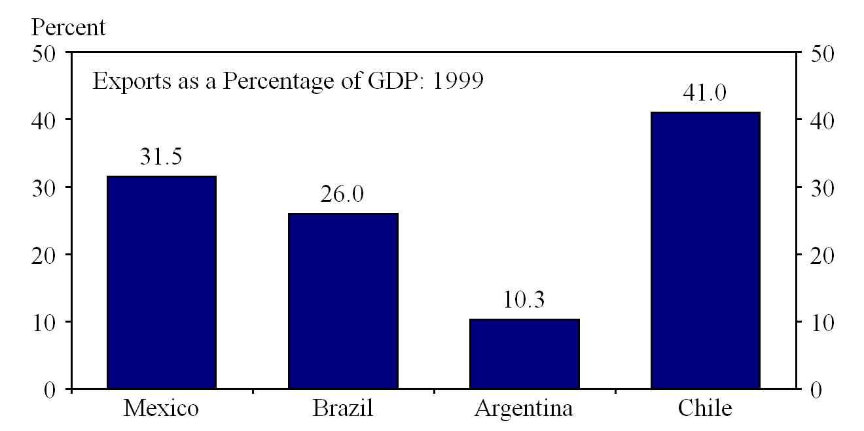

Current-account deficits remain more of a problem than fiscal shortfalls in this region. | 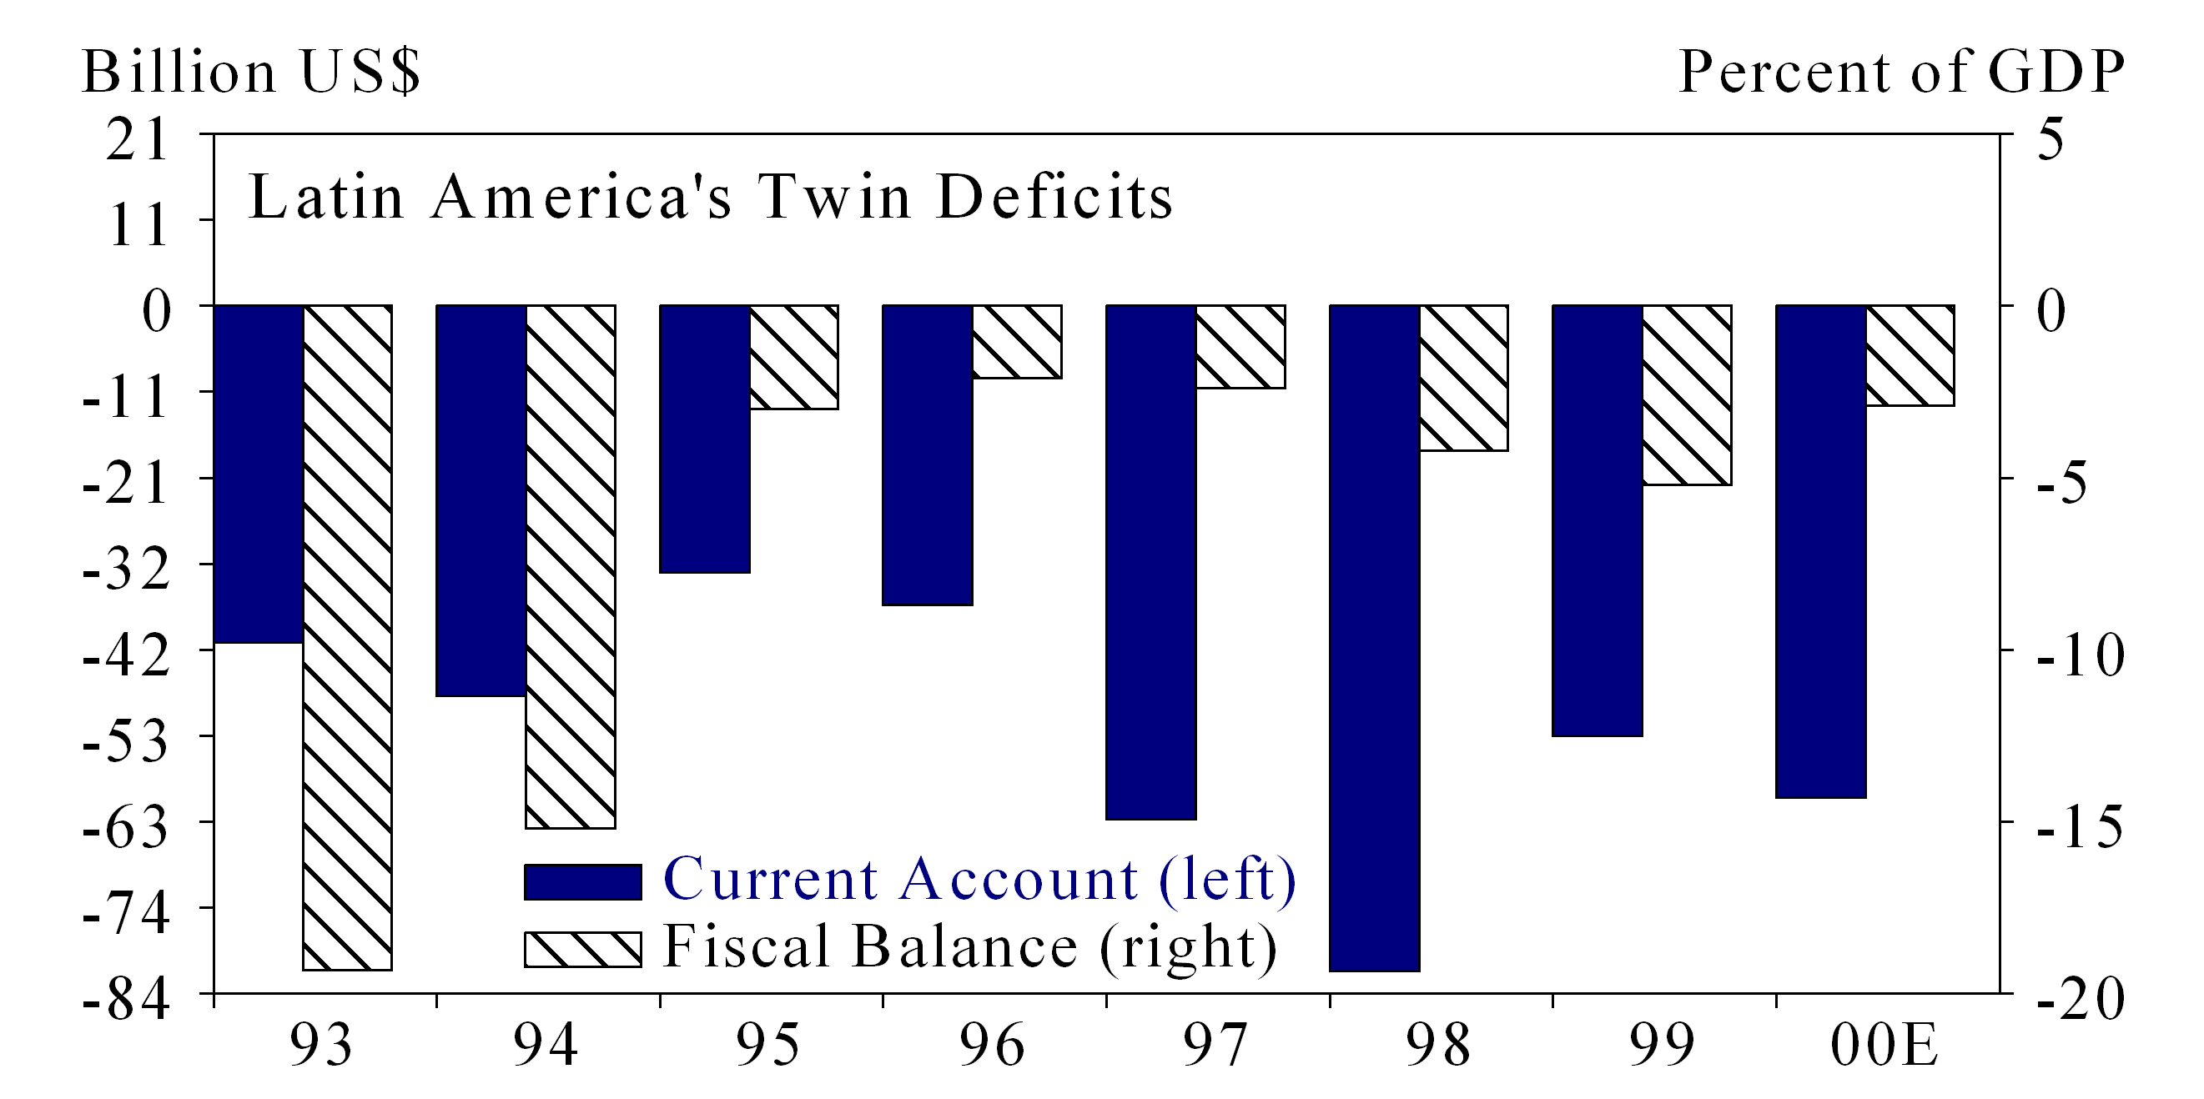

Latin America’s external financing needs are increasingly covered by foreign direct investment. | 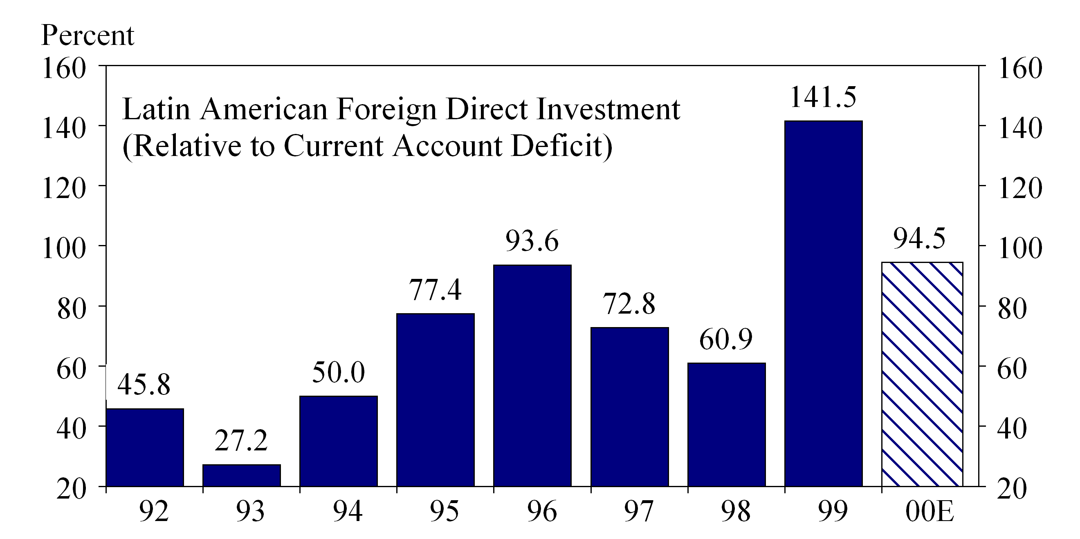

US Overview

- After five years of extraordinary vigor, we believe the US economy has slipped into a mild recession. After decelerating to a 1.5% pace in the three quarters ending in 1Q01, we now look for real GDP growth to contract by a 0.5% annual rate in the second and third quarters of this year before rebounding in the fourth quarter by just 2.5%.

- Risks remain on the downside of our short and shallow recession call. Three factors are most worrisome in this regard — the excesses of an IT overhang, a negative consumer wealth effect, and a current-account/dollar crisis. Should any of these pressures intensify, there is a distinct risk we could deepen and lengthen our recession call.

- In a still-subdued inflationary climate, a shortfall in volume growth should lead to significant pressure on corporate profits. This could well be exacerbated by a margin squeeze resulting from pressures on energy costs, financing costs, technology costs, and labor costs. Reflecting these concerns, we now look for after-tax corporate profits to contract by 11.0% in 2001 — a dramatic reversal from the 13.1% increase we estimate for 2000 and at odds with more optimistic earnings expectations still embedded in the stock market. This could heighten the risks of a further stock market correction and its concomitant wealth effect.

- Despite aggressive Fed easing, US recovery prospects should be restrained by the confluence of cyclical and structural factors. The former are traceable to the cost-cutting stemming from the ongoing earnings recession, and the latter reflect the post-bubble excesses of a negative personal saving rate, an outsized capacity overhang, and a record current-account deficit. The result could well be an “American-style L” -- with US GDP growth averaging just 1.5% to 2.0% over the 2001-03 interval.

US Forecast at a Glance

2000 2001E 2002E
(%, Year-Over-Year Change)
Real GDP 5.0 1.1 3.0
Inflation (CPI) 3.4 3.2 2.4
Industrial Production 5.6 -2.5 1.0
Capacity Utilization (%) 81.3 75.7 74.3
Corporate Profits (After-Tax) 13.1 -11.0 8.4
2001E 2002E
QI QII QIII QIV QI QII QIII QIV

(%, Sequential Quarterly Change at Annual Rates)
Real GDP 1.3 -0.5 -0.6 2.5 4.3 4.7 4.0 3.1
Gross Domestic Demand 0.0 0.2 -0.8 2.5 4.6 5.1 4.5 3.1
Unemployment Rate 4.2 4.6 4.9 5.0 5.0 5.0 5.0 5.1
E = Morgan Stanley Research Estimate

America Heading for Recession

Our baseline case calls for a short and mild recession, followed by a U-shaped recovery; risks remain to the downside.

An inventory correction seems likely to keep the economy contracting through mid-year.

The sharp slowing of the US economy over the past year falls short of the downturns that have sparked the V-shaped rebounds in the past.

Cost-Cutting at Work

This is likely to be an unusually steep earnings recession.

Cost-cutting initially has been focused on the pruning of capital spending, especially IT.

Businesses have just started to cut labor costs in an effort to boost profit margins.

* Peak tentatively designated as October 2000.

Purging Structural Excesses

An unprecedented decline in personal savings leaves the American consumer highly vulnerable to a negative wealth effect.

Driven by surging IT, there is a risk of a classic capacity overhang.

A savings-short US economy has become overly dependent on foreign capital to finance booming investment.

Capacity Overhang in the New Economy

Under the guise of the New Economy, America has embarked on a massive IT binge.

Much of this investment has been justified on the basis of increasingly shorter product cycles — a dubious assumption, in our opinion.

If IT spending slows, productivity gains could fade quickly.

Pruning White-Collar Bloat

Over the past 17 years, white-collar growth has averaged 2.3%, double the 1.1% growth in other occupations.

White-collar hiring has been increasingly skewed toward services and has become increasingly top-heavy with managers.

Within the white-collar function, back-office efficiencies have been offset by an ominous build-up of managerial bloat.

Consumers at Risk

As layoffs mount, the American consumer has turned increasingly skittish.

It will take a sharp consolidation of consumption to bring consumer demand in better alignment with purchasing power.

The excesses of consumption have been financed by a record surge in household debt.

Perils of the Wealth Effect

America’s growth dynamic is built on the shaky foundation of a still overvalued stock market and excessive reliance on foreign capital.

The $8 trillion appreciation in household equity holdings since late 1994 enticed wealth-dependent consumers into depleting their personal savings.

However, as pension regimes shift from defined-benefit to defined-contribution schemes, wealth preservation will likely become a paramount objective of individual investors.

Cyclical Dynamics

While real income growth remains solid, consumer confidence is starting to weaken — an ominous portent for the US economy.

Productivity growth typically slows at the end of a long-cycle expansion. | 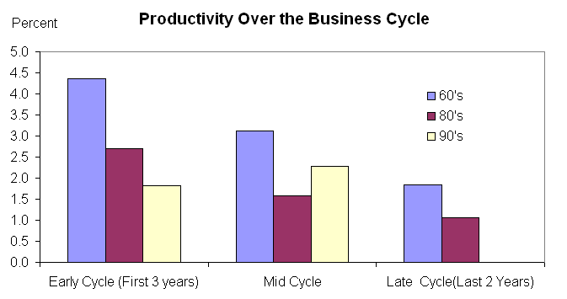

Consequently, we believe that there is still upside risk to unit labor costs.

Inflation Dichotomy

There is a marked contrast between the inflation dynamic in labor-intensive services and that in the goods-producing sector.

There has been a noticeable loss of pricing leverage in recent years.

Most still expect inflation to remain well below its secular norms.

Bond Market Risk

The recent rally in bonds reflects both a drop in real interest rates and a sharp reduction in the inflationary premium.

Unfortunately, a reduction in private saving appears to be offsetting the elimination of public sector “dissaving.”

A demographic time bomb will transform the social security surplus into deficit by 2015 under the baseline scenario, putting renewed pressures on America’s fiscal position.

The Cyclical Clock

There has been a dramatic lengthening of the business cycle over the past 140 years.

The current expansion has now exceeded the long-cycle outcomes of the 1960s and 1980s, making it the longest postwar expansion on record.

The current cycle may bear greater resemblance to those of the pre-World War II era than to those of the more recent period.

U.S. Economic and Interest Rate Forecast
Real GDP and Related Items, 2000-2002E Forecast Date: June 4, 2001
Percent Change
Year over Year Q4 to Q4* From Prior Quarter**
Actual
2000 2001E 2002E 2000 2001E 2002E 4Q00 1Q 01E 2Q 01E 3Q 01E 4Q 01E
Real GDP 5.0 1.1 3.0 3.4 0.7 4.1 1.0 1.3 -0.5 -0.6 2.5
Domestic Final Sales+ 5.6 2.0 3.1 4.5 1.4 3.9 2.2 2.9 -0.4 0.8 2.3
Personal Consumption Expenditures 5.3 2.5 2.7 4.5 2.0 3.0 2.8 2.9 0.8 2.2 2.0
Business Fixed Investment 12.6 -0.6 2.3 10.5 -4.3 7.6 -0.1 2.1 -7.7 -9.7 -1.4
-- Structures 9.1 7.2 -4.8 12.7 0.7 -3.6 10.4 17.2 4.3 -8.7 -8.0
-- Equipment 13.7 -3.1 5.0 9.8 -5.9 11.9 -3.3 -2.6 -11.6 -10.0 1.2
Residential Investment -0.5 0.2 15.9 -2.6 6.5 12.3 -3.6 2.9 -2.4 6.0 20.9
Exports 9.0 -0.2 4.3 6.7 -1.3 7.1 -6.4 -2.7 -3.5 -1.3 2.2
Imports 13.5 1.5 6.3 11.3 -0.1 7.9 -1.2 -9.1 3.1 3.6 2.8
Federal Government 1.5 2.8 2.7 -1.3 3.4 2.4 3.8 4.9 1.7 4.7 2.5
State & Local Government 3.5 2.1 1.6 2.7 1.8 1.9 2.5 4.7 0.0 0.6 2.0

Business Indicators++
Nominal Merchandise Trade Deficit $459.9 $461.8 $498.5 $488.1 $449.4 $461.7 $469.2 $467.1
Current Account as a % of GDP -4.4 -4.2 -4.4 -4.6 -3.9 -4.3 -4.4 -4.3
Change in Real Nonfarm Inventories 55.8 -14.3 21.4 50.5 -25.1 0.1 -19.5 -12.5

Housing Starts (Thous) 1,575 1,666 1,935 1,539 1,625 1,554 1,675 1,811
Light Vehicle Sales (Millions) 17.2 16.3 16.8 16.2 17.2 16.3 15.9 16.0
Industrial Production (Pct Chg) 5.6 -2.5 1.0 -0.9 -6.5 -3.6 -6.2 -1.8
Civilian Unemployment Rate (Percent) 4.0 4.7 5.1 4.0 4.2 4.6 4.9 5.0

After-Tax Profits $641.4 $570.8 $621.4 $626.4 $607.2 $572.8 $543.3 $559.9
-- Percent Change from Prior Year 13.1 -11.0 8.9 4.4 -4.3 -11.9 -17.0 -10.6
Disposable Personal Income (Pct Chg) 2.8 2.4 3.3 0.7 2.3 1.2 7.7 -0.1
Personal Saving Rate -0.1 -0.3 0.2 -0.7 -0.9 -0.8 0.4 -0.1

Prices and Costs (Percent Change)
GDP Chain Price Index 2.1 2.2 2.1 2.3 2.1 2.2 2.0 3.2 1.7 1.5 2.0
Consumption Prices ex Food & Energy 1.6 2.0 1.9 1.6 2.2 1.7 2.6 2.3 2.0 1.9 1.8
Consumer Price Index 3.4 3.2 2.4 3.4 2.9 2.5 2.9 4.2 3.4 1.7 2.4
Consumer Price Index ex Food & Energy 2.4 2.7 2.4 2.5 2.7 2.3 3.2 2.7 2.5 2.5 2.4
Producer Price Index 3.7 3.9 2.2 3.7 3.6 1.9 4.1 5.5 4.3 2.2 2.5
Compensation Per Hour 5.1 5.6 5.3 5.7 5.2 5.3 6.6 5.2 5.2 5.3 5.3
Productivity 4.3 1.2 2.5 3.3 0.4 3.3 2.0 -0.1 0.3 -0.4 2.0
Unit Labor Costs 0.7 4.4 2.7 2.3 4.8 1.9 4.5 5.2 4.9 5.7 3.2

*Annual average for Business Indicators +Final sales less net exports
**Annualized percent change from prior period, unless noted ++Billions of dollars; real in billions of chain-type 1996 dollars
E = Morgan Stanley Dean Witter Research Estimates
Interest Rate Outlook
Fed Funds LIBOR Treasury Yield Curve
Date* Target Prime 3-Mo. 3-Mo. 6-Mo. 2-Yr. 5-Yr. 10-Yr. 30-Yr.
May 31, 2001 4.00 7.00 3.99 3.61 3.56 4.17 4.90 5.37 5.75
01Q2 4.00 7.00 4.35 3.75 3.90 4.00 4.20 5.10 5.55
01Q3 3.75 6.75 4.15 3.60 3.78 3.95 4.11 4.90 5.30
01Q4 3.75 6.75 4.25 3.75 4.00 4.25 4.38 5.00 5.30

02Q1 4.00 7.00 4.50 4.00 4.30 4.60 4.73 5.20 5.30
02Q2 4.50 7.50 5.15 4.60 4.80 5.00 5.13 5.35 5.40
02Q3 5.00 8.00 5.60 5.00 5.05 5.10 5.23 5.45 5.45
02Q4 5.00 8.00 5.60 5.00 5.05 5.10 5.18 5.35 5.35
*All forecast values are for the end of the designated period.

Global Economic Outlook: GDP and Inflation 29-Jun-01
*All forecast values are for the end of the designated period. E = Morgan Stanley Estimates
 | GNP/GDP Growth (%) |  |  |  | CPI Inflation (%)
1998 1999 2000 2001E 2002E 1998 1999 2000 2001E 2002E

Global Economy 2.8 3.5 4.8 2.5 3.8 3.7 2.3 2.6 2.6 2.5
Industrial World 2.7 3.4 4.1 1.3 2.5 1.2 1.3 2.5 2.3 1.7
US 4.4 4.2 5.0 1.1 3.0 1.6 2.2 3.4 3.2 2.4
Australia 5.3 4.7 3.7 1.8 3.7 0.9 1.5 4.5 4.0 2.2
Canada 3.3 4.5 4.7 1.5 3.3 1.0 1.7 2.7 2.6 2.2
New Zealand –0.4 3.6 3.5 2.1 2.7 1.3 –0.1 2.6 2.6 1.9
Europe 2.8 2.5 3.3 2.1 2.7 1.4 1.2 2.4 2.4 1.8
EMU 2.8 2.5 3.4 2.2 2.7 1.1 1.1 2.3 2.6 1.6
Austria 3.3 2.8 3.2 2.1 2.4 0.9 0.6 2.3 2.6 1.6
Belgium 2.4 2.7 4.0 2.5 2.8 1.0 1.1 2.6 2.4 1.6
Denmark 2.8 2.1 2.9 1.5 1.9 1.9 2.5 3.0 2.1 2.3
Finland 5.5 4.0 5.7 3.0 4.5 1.4 1.5 3.4 2.7 2.0
France 3.5 3.0 3.3 2.5 2.8 0.7 0.5 1.7 1.6 1.1
Germany 2.0 1.6 3.0 1.5 2.5 1.0 0.6 1.9 2.6 1.6
Greece 3.7 3.5 4.1 3.2 4.0 4.8 2.6 3.2 3.0 3.2
Ireland 8.6 9.8 11.0 6.8 8.0 2.4 1.6 5.5 4.7 4.8
Italy 1.8 1.6 2.9 2.1 2.6 2.0 1.7 2.5 2.8 1.8
Netherlands 4.1 3.9 3.9 2.4 3.1 2.0 2.2 2.5 4.4 2.5
Norway 3.2 0.9 1.6 1.3 2.6 2.3 2.3 3.1 3.2 2.6
Portugal 3.8 3.3 3.3 2.8 3.0 2.8 2.3 2.9 3.8 3.2
Spain 4.3 4.0 4.1 2.8 3.2 1.8 2.3 3.4 3.7 2.5
Sweden 3.7 4.1 3.6 2.4 3.4 -0.1 0.5 1.4 2.3 1.9
Switzerland 2.4 1.5 3.5 1.8 2.2 0.0 0.8 1.6 1.4 1.3
UK 2.6 2.3 3.0 1.9 2.8 3.4 1.5 2.9 2.0 2.9

Emerging Europe 0.8 1.2 5.6 1.7 4.8 39.2 23.0 21.0 18.2 16.4
Czech Republic –2.3 –0.8 3.1 2.6 3.5 10.7 2.1 3.9 4.3 4.6
Hungary 4.9 4.5 5.2 4.1 4.5 14.2 10.0 9.8 8.9 6.5
Israel 2.3 2.1 5.8 1.6 4.2 5.5 5.3 1.1 0.5 2.1
Poland 4.8 4.1 4.1 3.4 4.7 11.8 7.3 10.1 6.2 5.8
Russia –4.9 3.2 6.7 4.1 5.3 84.4 36.6 20.5 15.0 10.0
Turkey 3.3 –5.1 7.2 -7.2 5.2 86.7 64.8 56.4 55.8 59.2
South Africa 0.6 1.2 3.1 2.6 3.1 6.9 5.2 5.3 5.9 4.0
Japan –1.1 0.8 1.7 -0.8 0.2 0.6 –0.3 –0.6 –0.8 –0.6
Asia Ex-Japan 2.1 6.5 7.3 5.4 6.5 6.2 1.7 1.5 2.4 3.3
China 7.8 7.1 8.0 7.5 7.8 –0.8 –1.4 0.4 1.0 3.0
Hong Kong –5.3 3.0 10.5 3.2 4.3 2.8 –4.0 –3.7 -1.0 1.0
India 6.4 6.4 5.7 6.4 6.5 13.2 4.8 4.2 4.5 5.1
Indonesia –13.1 0.8 4.8 2.7 4.0 58.0 24.1 3.8 9.0 6.5
Korea –6.7 10.9 8.8 4.5 6.5 7.5 0.8 2.3 4.1 3.0
Malaysia –7.4 5.8 8.5 3.0 5.0 5.3 2.8 1.6 1.7 2.5
Philippines –0.6 3.3 3.9 2.5 4.0 9.7 6.7 4.3 7.0 6.0
Singapore 0.1 5.9 9.9 4.1 7.0 –0.3 0.4 1.3 1.3 2.0
Taiwan 4.6 5.4 6.0 2.5 4.5 1.7 0.2 1.3 1.0 2.0
Thailand –10.2 4.2 4.3 2.0 4.5 8.1 0.3 1.6 2.0 2.5
Latin America 2.1 0.1 4.3 3.2 4.4 9.4 8.6 6.5 5.5 5.4
Argentina 3.9 –3.4 -0.5 2.0 3.0 0.7 –1.8 –0.7 0.5 1.0
Brazil 0.2 0.8 4.5 3.6 4.0 1.7 8.9 6.0 5.1 4.7
Chile 3.9 –1.1 5.4 4.5 5.5 4.7 2.3 4.5 3.5 3.0
Colombia 0.5 –4.3 2.8 3.0 3.5 16.7 9.2 8.7 9.5 9.0
Mexico 4.9 3.8 6.9 3.0 6.2 18.6 12.3 9.0 5.5 4.5
Peru -0.4 1.4 3.6 0.5 3.0 6.0 3.7 3.7 4.0 4.0
Venezuela 0.2 –6.1 3.2 5.0 3.0 29.9 20.0 13.4 15.0 20.0

Global Economic Outlook: Interest Rates, Bond Yields, and Currencies

 | 3-Month Euro Rates (%) |  | 10-Year Bond Yields (%) |  | Exchange Rates
Jun 29 Sep01 Dec01 Mar02 Jun 29 Sep01 Dec01 Mar02 Jun 29 Sep01 Dec01 Mar02

G-3 Countries
US 3.8 3.9 4.0 4.4 5.4 5.3 5.4 5.5
Euro 4.4 4.1 4.1 4.3 5.0 4.8 5.3 5.5 0.85 0.96 0.91 0.95
Japan 0.08 0.10 0.10 0.10 1.2 1.1 1.0 1.1 124 120 115 110

Dollar Bloc
Canada 4.4 4.2 4.3 4.6 5.9 5.6 5.7 5.7 1.52 1.56 1.50 1.48

Non-EMU Europe
Denmark 4.8 4.5 4.5 4.6 5.3 5.0 5.4 5.6 7.45 7.46 7.46 7.46
Switzerland 3.1 2.8 2.8 2.8 3.3 3.3 3.6 3.8 1.52 1.56 1.52 1.56
Sweden 4.5 3.9 3.6 3.6 5.3 5.4 5.2 5.1 9.18 9.25 8.70 8.80
UK 5.2 5.0 5.1 5.4 5.3 5.2 5.4 5.6 0.60 0.66 0.66 0.67
$/GBP 1.41 1.45 1.38 1.42
Note: Data are end-of-period values. European exchange rates are against the Euro except where noted. E = MSDW Research Estimates
More detailed exchange rate forecasts are available in Morgan Stanley’s FX Pulse weekly.

May 29, 2001.
Tipping Point

Stephen S. Roach (Stephen.Roach@msdw.com)
Tipping Point is a delightful little book by Malcolm Gladwell that made the rounds last year. The thesis is simple and inarguable: Under certain critical conditions, the cumulative effect of lots of little things can eventually make a big difference. Based on the principles of epidemics, Gladwell maintains that many tectonic changes in the world have come about from very small origins — from product breakthroughs (Hush Puppies) and criminal activity (New York City’s falling crime rate) to technological change (cell phone penetration) and medical discoveries (cancer treatments). The tipping point comes at the moment a slowly starting dynamic reaches a critical mass and then boils over into an irreversible sea change. I am beginning to suspect that the world economy is nearing a critical tipping point, one that could pose a formidable challenge to the US-led strain of globalization.
The Law of the Few. Gladwell has identified three rules of the tipping point, each of which may well be applicable to what lies ahead. The first is the Law of the Few — that epidemics start small, and their transmission is dependent on the unique nature of the messenger. The US-led downturn in the global economy fits this script to a tee. America went from boom to bust in just six months, and the rest of the world has been quick to follow. Underscoring that point, we have again cut our below-consensus global growth forecast, trimming our 2002 estimate for world GDP growth to 3.7% from 3.9%. At work are downward adjustments to Euroland, the UK, Malaysia, Hong Kong, and Taiwan. Once again, I would stress that we may not be done yet. I would continue to place the downside risks to our 2002 global growth forecast in the 3.0–3.5% range.
Moreover, our downward revisions to 2002 follow yet another reduction to our near-term prognosis. We have just pared our 2001 GDP forecast for Mexico, to 3.0% from 3.3%, and we think the odds are rising that currency-induced pressures on Argentina will spill over into Brazil. Nor does there appear to be any let-up in sight from the original instigator of this global slowdown — the United States. That was hammered home by a downward revision to the government’s original estimate of 1Q01 GDP growth, to 1.3% from 2.0%. On a revised basis, we now expect world GDP growth to average 3.2% over the 2001–02 interval — 0.5 percentage point below the longer-term trend of 3.7%. The persistence of such subpar growth is what could lead to a tipping point.
The Law of the Few tends to spread because of what Gladwell calls “connectors.” Globalization, of course, rests on the foundations of such connectivity — through capital markets, cross-border trade, and information technology. Thus, contagion is likely to be the rule rather than the exception. That’s especially the case as the world economy loses its major source of dynamism, a once high-flying US economy. With the rest of the world lacking in self-sustaining domestic demand growth — especially an IT-dependent Asia, a NAFTA-dependent Canada and Mexico, and a global-trade-dependent Europe — it is all the more susceptible to a US-led downshift. Lacking a candidate to fill the void, an engineless world is more vulnerable to contagion than a more balanced world would be.
The world economy could be nearing a critical tipping point that challenges the US-led strain of globalization.

The Stickiness Factor. The second rule of the tipping point is the Stickiness Factor — the tendency of an important trend to become increasingly entrenched as it spreads. That’s what the globalization of the New Economy is all about. The rapid growth of e-based connectivity makes it virtually impossible to turn back the clock on this new era of global commerce. The worldwide build-out of a telecommunications infrastructure is a given. The questions pertain more to efficiencies on the supply side — both profitability and capacity excesses — than to the demand side of this equation. Like it or not, such stickiness probably solidifies the dependence of the rest of the world on this US-led strain of globalization.
So, too, does the rapid expansion of global trade. By our calculations, world trade hit a record of close to 25% of global GDP in 2000, more than four times the share prevailing in 1970. Now this trade dynamic is running in reverse. Our estimates suggest that the nearly 13% surge in 2000 will be more than cut in half in 2001. The confluence of e-based and trade linkages underscores the stickiness of globalization — yet another reason to stress the heightened possibility of cross-border spillovers, or contagion.
The Power of Context is the third ingredient of Gladwell’s tipping point. It speaks mainly of the sensitivity of individuals to their environment — and to forces that may prompt unexpected and/or unusual reactions to such conditions. Here, again, the context is globalization. As I see it, the individual sensitivities that most stand out could well be on the dark side of globalization, namely, widening income disparities between the haves and the have-nots. The risk is that these growing inequalities could worsen in the context of the new strain of globalization. That could arise from the “digital divide” — whereby the profusion of new information technologies exacerbates the disparities between the computer literate and those lacking such skills. That sets up a tug-of-war, not only within nations but also across borders, that could strain the fabric of globalization.
Those tensions seem likely to be all the more acute in a sluggish growth climate. It’s not that vigorous growth is the rising tide that lifts all boats. But to the extent that it does spark rapid hiring and income generation, it can temporarily mask economic hardship. Sluggish growth, by contrast, unmasks the pain. The new math of the New Economy leaves little doubt of how this downside plays out. In the boom phase, scale and scope were everything. Hypergrowth was the stuff of open-ended IT spending and rapid hiring. The math of subpar growth turns these trends inside out. As growth slows, cost excesses must come out of the system, eliminating overhangs in both capital accumulation and hiring. In the jargon of the tipping point, rapid growth is a very favorable context for globalization. The risk is that subpar growth may not be.
What are the implications of such a backlash? Three key possibilities come to mind — the first being that trade liberalization might give way to some form of protectionism. To the extent that slow growth prompts mounting layoffs, the political winds could well shift. The outcome might lead to the erection of new competitive barriers that would supposedly shield workers from the harsh winds of globalization. The body politic is already sympathetic to just such a possibility. From Seattle to Quebec City, recent demonstrations of antiglobalists drive this point home. So, too, do public opinion polls revealing that US workers oppose several aspects of globalization — especially trade liberalization, immigration, and foreign direct investment. Even during goods times, according to these polls, the benefits of such trends are thought to be largely outweighed by the costs. In tougher economic times, that resistance can only intensify. Protectionism is antithetical to everything that globalization stands for. However, if a backlash arises, protectionism could be the gravest risk of all.
Second, any ascendancy of labor could well push the pendulum of economic power away from the decidedly pro-capital position it has occupied for much of the past decade. The effects of such a development could be manifested in two forms — sustained corporate earnings pressure and/or higher inflation. Inasmuch as a persistently sluggish global economy hardly points to a restoration of pricing leverage, the cost pressures arising from a backlash should take a disproportionate toll on business profits. In the climate we envision, such cost pressures will squeeze margins rather than trigger inflation. Inflation scares will turn out to be false alarms, and earnings rebounds will end up being short-lived.
A third potential impact of such a backlash could show up in the form of an especially sharp toll on the perceived rates of return on dollar-denominated assets. The dollar looks especially vulnerable to me in this regard. I am the first to concede that I have held this view for longer than I care to remember. Yet I continue to believe that the offshore overhang of US dollars brought about by a record current-account deficit leaves the United States highly vulnerable to the whims of ever-fickle global investors. I still maintain that the day will come when global investors demand a premium for holding dollar-denominated assets. When that occurs, then something has to give — either the dollar, US equity prices, or bond yields, or some combination of the above. Financial markets are totally unprepared for such a possibility.
Tipping Point is a great read and a provocative intellectual exercise. It is also well grounded in reality, fitting the script of many a Big Change in the world. Like all such historical analytics, however, it works best after the fact, lending itself all too well to the classic rearview mirror critique. The problem, of course, is knowing whether a tipping point is actually at hand for the global economy. That’s what intrigues me the most. The US has been on an extraordinary ride, and the rest of the world may simply have become overly dependent on the American way. It is the excesses of that ride — and their likely purging — that might lie at the heart of the next tipping point.

The New Global Contagion June 19, 2001

Stephen S. Roach (Stephen.Roach@msdw.com)

The global currency crisis of 1997–98 was widely billed as the first recession of the era of globalization. Like a fast-moving epidemic, the contagion of cross-border currency depreciation swept the world for 18 months — from Thailand in mid-1997 to Brazil in early 1999, and many points in between. Today, a new strain of contagion is at work. And it could be even more lethal than the financial-market contagion that afflicted the world 3–4 years ago. It’s a contagion across the real economies of the world, transmitted by the confluence of cross-border trade, globalized supply chains, and multinational corporations. And the risk is that this new global contagion has only just begun.
The impact of a US-led economic slowdown on the rest of the world is one major channel for this new strain of contagion. America’s role in precipitating this contagion is underscored by the downward revisions we have made to our global forecast in recent months. Our 2001 world GDP growth estimate now stands at 2.4%, down sharply from the 4.2% prognosis that prevailed as recently as October 2000. Fully 35% of that reduction is traceable to the direct effects of cuts we have made to our US growth estimates; our current US GDP growth forecast for this year stands at just 1.1% — less than one-third the 3.7% growth pace we were forecasting last fall. The balance of the reduction to our 2001 global growth forecast stems from cuts we have made to the rest of the world, especially Europe, non-Japan Asia, and Latin America. Moreover, we have just cut our below-consensus 2001 growth prognosis for Japan to –0.8% from +0.2%.
It should be no surprise that the US economy has led the world to the downside. After all, it played a disproportionate role in driving global growth for the past five years. In 1995 through 2000, our estimates suggest that the 4.5% average annual expansion of the US economy directly accounted for 26% of the cumulative increase in world GDP. Adding in the indirect effects of US imports from non-Japan Asia, its NAFTA partners, South America, and Europe, the US appears to have accounted for about 40% of the total increase in world GDP over the five years ending in mid-2000. Courtesy of the dramatic slowdown in the US economy that has subsequently occurred, that 40% contribution is now in the process of going to zero. Moreover, with Japan back in recession, non-Japan Asia getting hit hard by the downturn of the US information-technology (IT) cycle, and the European manufacturing recession starting to broaden out, the world economy is essentially engineless — lacking a new source of growth to fill the void left by a once-booming US economy. Without an alternative growth engine, the global economy is probably now in recession.
A new strain of global contagion is at work — driven by world trade, globalized supply chains, and powerful multinational corporations.

To a large extent, this global recession is traceable to a new strain of contagion — enhanced connectivity that both amplifies and accelerates the linkages between the real economies of the world. Three types of linkages are at work, the first being cross-border trade. According to our estimates, global trade now accounts for nearly 25% of world GDP, essentially double the share prevailing in the 1970s. With the major economies of the world simply trading more with each other, fluctuations in one country quickly spill over into other countries. That’s especially the case when the world’s largest economy — the United States — screeches to a virtual standstill as it did in the latter half of 2000. Foreign trade accounted for about 15% of US GDP in 2000, nearly double the share prevailing over the 1980s. This increased openness of the US economy is a double-edged sword; when America booms, the rest of the world benefits, but when America sneezes, the rest of the world can quickly catch a cold.
Increasingly globalized supply chains are a second characteristic of the new global connectivity that magnifies the cross-border impacts of a US-led slowdown. This, of course, is a by-product of the worldwide trend toward outsourcing — the creation of a network of offshore suppliers that reduces the cost of production in the industrial world. Non-Japan Asia has led the charge as the world’s leading IT outsourcer. Our greater China economist Andy Xie estimates that IT exports to the US accounted for as much as 40% of non-Japan Asia’s total GDP growth in 2000. America’s NAFTA-based supply chains are just as well developed. US exports account for 25% of Mexican GDP and 32% of Canadian GDP. Given the extent of the linkages in global supply chains, America quickly exports the macro impacts of any inventory adjustments to its offshore outsourcers. Little wonder that growth prospects are now fading quickly in non-Japan Asia, Mexico, and Canada. Those are the footprints of the new global contagion.
The increased role of multinational corporations in the world economy is a third means by which the new global contagion is conveyed. Joe Quinlan, our resident expert on trans-national flows of multinational corporations, has long stressed that the trade statistics on exports and imports seriously understate the full extent of commercial linkages that bind the world’s economies together. Of far greater importance in driving cross-border linkages are the combined balance-sheet impacts of foreign direct investment and foreign affiliate sales and transfers of multinational corporations. This is particularly the case in Europe, which accounts for 75% of all earnings of US-based affiliates of multinational corporations. Significantly, sales of Europe’s US-based affiliates were running at nearly four times the pace of US imports from Europe in 1998 (latest data available). For that reason, alone, Europe’s direct exposure to the US through cross-border trade — with Euroland exports to the US accounting for only 2% of the region’s GDP — misses the true vulnerability of the region to a US-led downturn (also see comment by Charles de Boissezon). The American downshift is hitting the US subsidiaries of European multinationals especially hard. That, in turn, puts pressure on the parent to cut costs in order to shore up global earnings. Add to that the 15% share of Euroland GDP that goes to exports — greater than shares in either the US or Japan — and it’s not terribly difficult to fathom why the European economy is now slowing noticeably.
The US response to global weakening is another manifestation of the new strain of contagion bearing down on the global economy. With the growth dynamic in the rest of the world slipping ominously toward recession, risks are building of unexpected weakness on the US-export front — driven not just by slippage in the external growth climate but also by the lagged impacts of the prolonged strengthening in the US dollar. We are currently looking for US exports to rebound by 7% over the four quarters of 2002. In light of the rapidly deteriorating global climate, I believe that the risks are tipping decidedly to the downside of this forecast.
In past recessions, the peak cyclical decline in real US exports was in the 6–20% range. There were two exceptions in the last 50 years — the recession of 1990–91, when export growth slowed to an anemic positive comparison of around 3%, and the contraction of 1960–61, when exports declined by only about 2%. But exports generally decline during a global recession, and I am hard-pressed to believe that this time will be an exception. The same verdict comes through loud and clear in our own internal estimates of global trade. We now reckon that world trade growth will slow to just 4.3% in 2001, one-third the 12.8% growth pace of 2000. That would represent the sharpest year-to-year slowdown in global trade on record. The case for US export resilience in such a climate is a stretch, to say the least.
All this suggests that there could still be several shoes yet to fall in the US economy. The American consumer is high on everyone’s watch list, but, in my opinion, exports aren’t too far behind. With exports accounting for about 11% of the US economy, our forecast of 7% export growth in 2002 accounts for nearly 20% of the 4% growth in overall GDP we are estimating over the four quarters of next year. That means every five-percentage-point shortfall in export growth — not an unreasonable assessment of the downside risks to our own forecast, in my view — would translate into a 0.5 percentage point haircut on overall GDP growth. Of course, any such shortfall would then trigger a new round of global repercussions through America’s offshore supply chain, further exacerbating the downshift in the world economy through yet another wave of cross-border contagion.
There can be little doubt of America’s outsized role in sparking the current global downshift. The very fabric of globalization is woven with the threads of increased world-trade linkages, newly globalized supply chains, and the growing scope of multinational corporations. In an upcycle, such connectivity is the stuff of virtuous circles. In a downcycle, the circle quickly turns vicious. Courtesy of the new contagion of globalization, these shifts are now coming faster and with greater force than ever before.
On the heels of the US growth crunch, the world has gone from boom to bust in less than a year. Sure, the authorities are trying to kick-start the US and the broader global economy. But just as virtuous circles tend to last longer than we think, the same could be true of the vicious circle. Such are the perils of the new global contagion.

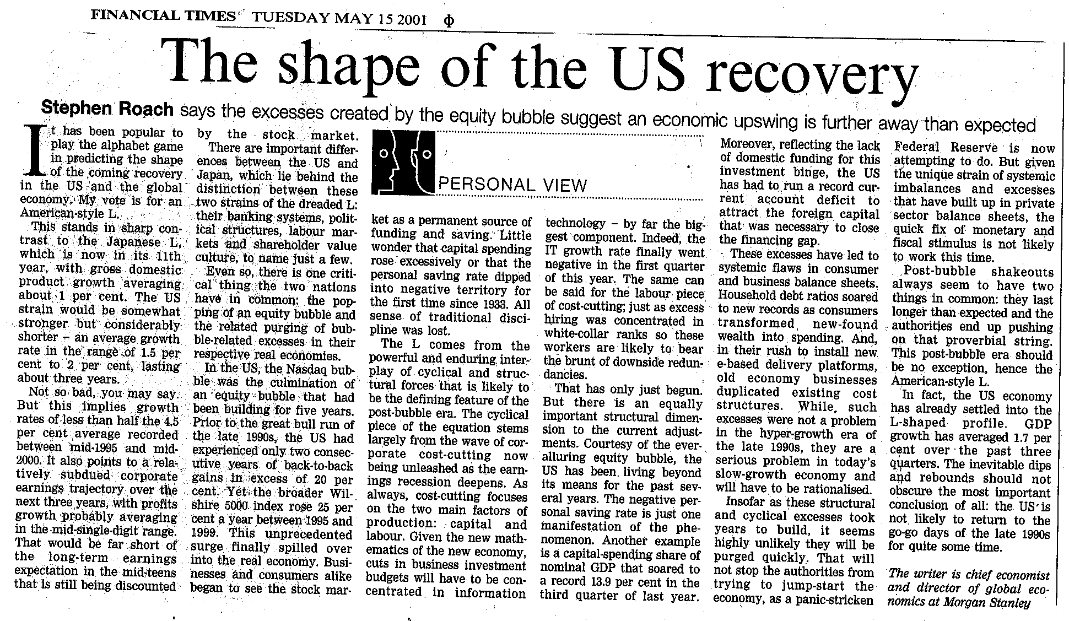

(DO NOT DELETE THE FOLLOWING SECTION BREAK OR ADD TEXT BEYOND THIS POINT – [This is hidden text. It will not print])

____________________________________________________
The information and opinions in this report were prepared by Morgan Stanley & Co. Incorporated (“Morgan Stanley”). Morgan Stanley does not undertake to advise you of changes in its opinion or information. Morgan Stanley and others associated with it may make markets or specialize in, have positions in and effect transactions in securities of companies mentioned and may also perform or seek to perform investment banking services for those companies. This memorandum is based on information available to the public. No representation is made that it is accurate or complete. This memorandum is not an offer to buy or sell or a solicitation of an offer to buy or sell the securities mentioned.
Morgan Stanley & Co. Incorporated, Morgan Stanley DW Inc. and/or their affiliates or their employees have or may have a long or short position or holding in the securities, options on securities, or other related investments of issuers mentioned herein.
The investments discussed or recommended in this report may not be suitable for all investors. Investors must make their own investment decisions based on their specific investment objectives and financial position and using such independent advisors as they believe necessary. Where an investment is denominated in a currency other than the investor’s currency, changes in rates of exchange may have an adverse effect on the value, price of, or income derived from the investment. Past performance is not necessarily a guide to future performance. Income from investments may fluctuate. The price or value of the investments to which this report relates, either directly or indirectly, may fall or rise against the interest of investors.
To our readers in the United Kingdom: This publication has been issued by Morgan Stanley and approved by Morgan Stanley & Co. International Limited, regulated by the Securities and Futures Authority Limited. Morgan Stanley & Co. International Limited and/or its affiliates may be providing or may have provided significant advice or investment services, including investment banking services, for any company mentioned in this report. Private investors should obtain the advice of their Morgan Stanley & Co. International Limited representative about the investments concerned.
This publication is disseminated in Japan by Morgan Stanley Dean Witter Japan Limited and in Singapore by Morgan Stanley Dean Witter Asia (Singapore) Pte.
To our readers in the United States: While Morgan Stanley has prepared this report, Morgan Stanley & Co. Incorporated and Morgan Stanley DW Inc. are distributing the report in the US and accept responsibility for it contents. Any person receiving this report and wishing to effect transactions in any security discussed herein should do so only with a representative of Morgan Stanley & Co. Incorporated or Morgan Stanley DW Inc.
To our readers in Spain: Morgan Stanley Dean Witter, SV, SA, a Morgan Stanley group company, supervised by the Spanish Securities Markets Commission (CNMV), hereby states that this document has been written and distributed in accordance with the rules of conduct applicable to financial research as established under Spanish regulations.
To our readers in Australia: This publication has been issued by Morgan Stanley but is being distributed in Australia by Morgan Stanley Dean Witter Australia Limited A.B.N. 67 003 734 576, a licensed dealer, which accepts responsibility for its contents. Any person receiving this report and wishing to effect transactions in any security discussed in it may wish to do so with an authorized representative of Morgan Stanley Dean Witter Australia Limited.
To our readers in Canada: This publication has been prepared by Morgan Stanley and is being made available in certain provinces of Canada by Morgan Stanley Canada Limited. Morgan Stanley Canada Limited has approved of, and has agreed to take responsibility for, the contents of this information in Canada.
Morgan Stanley is a service mark of Morgan Stanley Dean Witter & Co. Additional information on recommended securities is available on request. This report may not be resold or redistributed without the prior written consent of Morgan Stanley Dean Witter & Co.

